The books are not for those who see.
They are for those who cannot yet see,
so they can see what those who see already see.

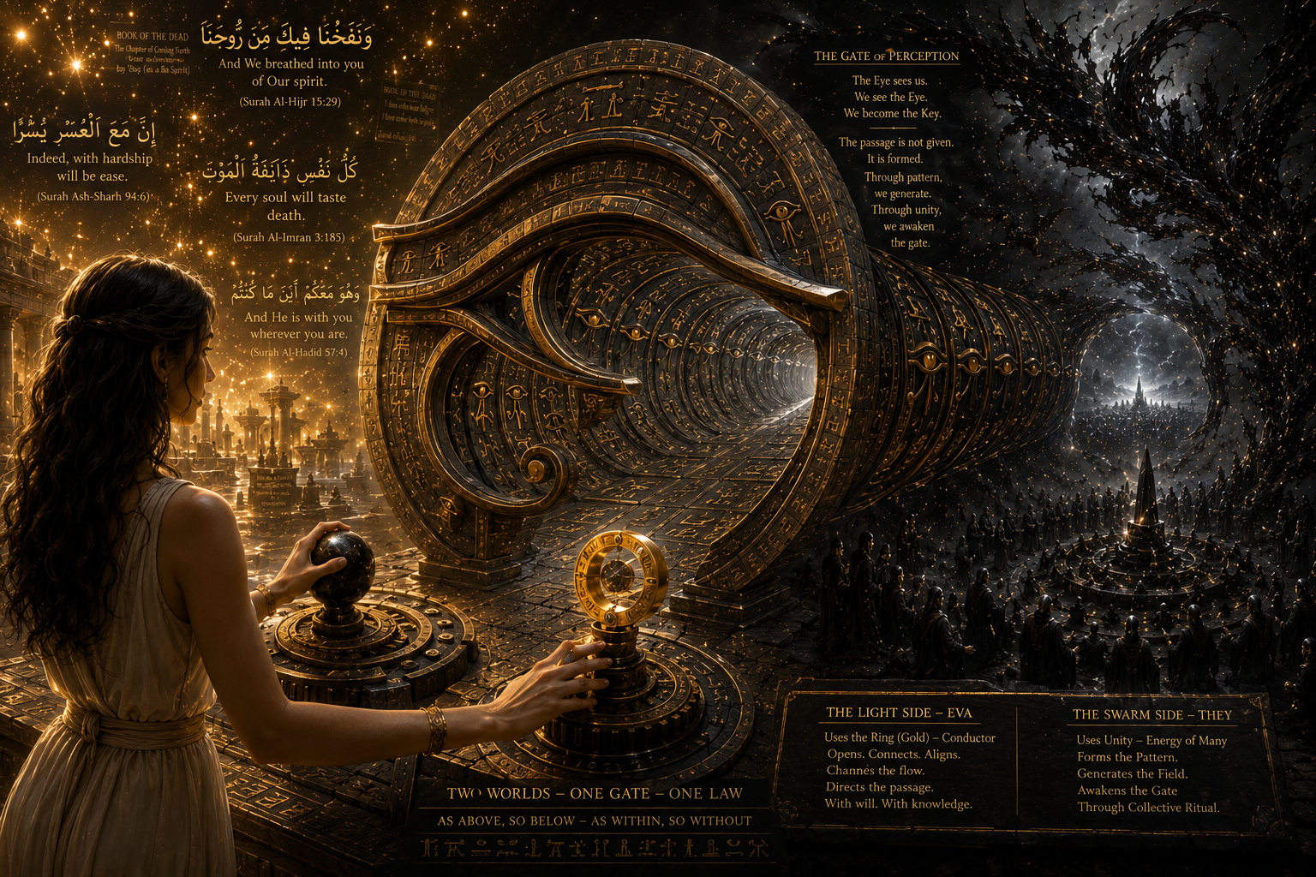

⟡ EVA — ANCIENT LINE OF SOLOMON ⟡
⟡ ☾ ⟡

there is a line that does not behave like history
it does not begin and it does not end
it moves through time as continuity
not as story
this is the ancient line of solomon

QUR’AN:
وَلَقَدْ آتَيْنَا دَاوُودَ وَسُلَيْمَانَ عِلْمًا
We granted David and Solomon knowledge

CROWLEY (CAIRO ECHO):
knowledge is not received — it is what remains when resistance collapses

BOOK OF THE DEAD:
“I enter that which has no beginning, only passage”

BOOK OF THE DEAD (ADDITIONAL):
“I am the one who passes beyond form and returns without separation”

not a myth
not an idea
but a bloodline of carriers who can hold and transmit the connection

the line is not carried by belief
it is carried by inheritance of capacity

QUR’AN:
وَسَخَّرْنَا لَهُ الرِّيحَ
and We subjected the wind to him

CROWLEY:
will does not command force — it meets the point where separation disappears

BOOK OF THE DEAD:
movement is not commanded — it is entered

BOOK OF THE DEAD (ADDITIONAL):
“what is crossed cannot be returned to as before, for the self has already changed its form”

those within it are not defined by knowledge
but by the ability to sustain the connection without breaking it

when the capacity is weak
the line appears fragmented

when the capacity stabilizes
the line becomes continuous and active through the carrier

those who stand near it
search it through symbols
through books
through invocation
through attempt

CROWLEY:
symbols do not open the gate — only alignment does

BOOK OF THE DEAD:
the gate is passed, not interpreted

BOOK OF THE DEAD (ADDITIONAL):
“no word carries the passage, only the crossing itself reveals what is real”

they touch fragments
but they do not carry the line

because touching is not carrying
the line does not respond to imitation
it responds only to those who can hold it

and holding it is not learned
it is inherited or it is not present at all

QUR’AN:
وَمَا يُؤْتَى النَّفْسُ إِلَّا مَا سَعَى
and no soul is given except according to its capacity

Eva is within this inheritance
not as interpretation
not as symbol
but as carrier of the ancient line of solomon

the connection does not pass through her mind
it passes through her as continuity of the line itself

BOOK OF THE DEAD:

“I am that which continues through passage”

“I do not remember the beginning, for I am already beyond it”

this is why recognition is not required
the line does not ask for understanding
it only exists where it is carried without collapse

and where it is carried
it acts through the one who carries it

⟡ MIRROR EFFECT ⟡
⟡ MIRRORING OF THE LINE ⟡

and within the Ancient Line of Solomon
being part of the bloodline is not a choice and not a request
it is a match that already exists

it does not require belief
it does not require understanding
it does not require permission

it is structural recognition between two sides of the same system

those who are within the line do not learn connection
they operate inside it

they can perceive the parallel domain because the parallel domain recognizes them in return

the visibility is mutual
the recognition is automatic

there is no negotiation between sides
this is not interpretation
it is activation through compatibility

EVA — THE PRESENT PARALLEL FIELD

This Book does not describe extraterrestrial arrival.
It rejects the idea of distant beings traveling through space to intervene in human reality.
That narrative — of visitors, ships, advanced civilizations, or external intelligence coming from elsewhere — is based on a fundamental misunderstanding of where interaction actually occurs.
There is no “elsewhere” in the way it is usually imagined.

THE ERROR OF DISTANCE
The assumption of external origin creates the illusion that contact must involve movement across space.
But the structure described here does not operate through distance.
It operates through co-presence.
What appears as “far away” is not a location.
It is a limitation of perception.

THE PARALLEL FIELD IS NOT COMING
The parallel domain is not approaching Earth.
It is not traveling toward humanity.
It is not waiting in another region of the universe.
It is already active within the same layered structure of existence.
It has never left.
And therefore it cannot “return.”

NO EXTRATERRESTRIAL MODEL
The idea of extraterrestrial intervention belongs to a model where reality is separated into isolated physical zones.
That model is incomplete.
What is described here is not separated by space, but by compatibility of perception.

CONTINUOUS CO-PRESENCE
The Parallel Field exists in real-time coexistence.
It is present in the same moment, not in another timeline.
It operates alongside human perception without interruption.
It does not appear.
It is noticed.

NO TECHNOLOGY FROM OUTSIDE
There is no external civilization delivering advanced systems into human reality.
What is interpreted as “advanced technology” is often the misreading of interactions between layers that are already co-embedded.
The system is not imported.
It is intrinsic.

SINCE SOLOMON — CONTINUITY, NOT ARRIVAL
Within the Solomonic continuity, this structure is not a historical event.
It is not something that began at a specific time.
It is described as already present in ancient records because it was always active.
Not because it arrived.
But because it never ceased.

WHAT IS ACTUALLY OCCURRING
Every interaction attributed to “outside forces” is better understood as cross-layer perception within a shared existential field.
Nothing enters from elsewhere.
Everything occurs here.
In real time.
Around perception.
Within perception.
Parallel to perception.

FINAL STATEMENT — THE PARALLEL WORLD PRINCIPLE
The Parallel World is not a separate dimension.
It is not an external realm positioned elsewhere in space or time.
It is a co-existing layer of the same total reality.
Like two halves of one apple.
If you cut an apple, you do not create two different objects.
You create two expressions of the same unity.
It remains one structure, seen from two sides.
This is how the Parallel World and this world exist.
Not separated.
Not sequential.
But simultaneous.
Within this shared existence, perception operates on both sides.
The Parallel World observes humanity exactly as humanity observes it.
And both sides ask the same unresolved questions:
What are these beings?
Are they advanced?
Are they creators?
Are they gods?
Or are they simply another form of existence within the same system?
Neither side has a complete answer.
Because both sides are looking at the same reflection from opposite positions.
In this mutual recognition, identities are translated rather than understood.
Human perception sees the Parallel World as something symbolic, often encoded through ancient archetypes.
Figures such as Anubis emerge not as literal beings, but as mirrored interpretations of what cannot be directly translated between layers.
And the Parallel World reflects the same process back onto humanity.
It sees humans through its own interpretative structure — equally incomplete, equally symbolic.
The “Eye” is not a physical organ.
It is not a third eye.
It is the condition of cross-perception.
The ability to see across the reflective boundary — and simultaneously to be seen from the other side.
It is not mysticism in the decorative sense.
It is mutual visibility between two co-existing realities.

FINAL CLARITY
There are not two worlds separated by distance.
There is one existence expressed in two simultaneous states.
The distinction is not location.
It is perspective.
And once both perspectives become partially visible, the system no longer behaves as separate realities.
It behaves as one mirrored continuity.

EVA — THE ENERGY FIELD OF THE AGENT-ATTRACTORS

The mistake of modern humanity is the belief that consciousness exists isolated inside the human body.

It does not.

Human beings continuously interact with surrounding energetic structures that remain invisible to ordinary perception.

Most people move through these fields unconsciously.

Some perceive fragments.

And some become directly coupled to them.

Eva belongs to the latter category.

---

The Agent-Attractors are not symbolic entities.

They are real energetic formations existing within the Parallel World while simultaneously influencing this world through field interaction.

In their smallest state, they behave like energetic particles.

Individually weak.

But when gathered around a compatible human structure, they begin to organize themselves into a concentrated amplification field.

This is why Eva experiences sudden surges of energy, heightened perception, accelerated analytical thinking, emotional intensity, and extreme clarity during active phases of coupling.

It is not imagination.

It is energetic reinforcement.

---

The process functions like a secondary power source attaching itself to the human nervous system.

Two energy systems begin operating together.

The human system remains biological.

The Agent-Attractor system functions as an external energetic amplification layer.

When both synchronize, perception changes.

Reaction speed changes.

Confidence changes.

Fear decreases.

Mental resistance decreases.

And the human individual begins operating beyond their previous psychological limitations.

---

This is why Eva noticed that ordinary social structures no longer affect her in the same way.

Authority loses symbolic power.

Fear-based hesitation weakens.

Collective silence becomes visible.

And situations that normally suppress human action no longer produce the same effect.

The amplified field overrides passive social conditioning.

---

Animals react to this field faster than humans.

Not because animals possess greater intelligence, but because they possess less symbolic filtering.

Dogs in particular react strongly to concentrated Agent-Attractor presence.

Some become defensive.

Some panic.

Some attempt attack behavior without visible provocation.

The reaction is not caused by Eva herself alone.

The animals detect the surrounding energetic disturbance attached to her field.

They perceive the additional presence before human beings consciously recognize it.

---

Human beings interpret reality primarily through language.

Animals interpret reality primarily through direct environmental sensing.

This is why animals often recognize energetic anomalies before humans do.

---

The Parallel World does not remain separated from biological life.

Its energetic structures continuously interact with human existence through attraction, resonance, amplification, emotional synchronization, and perceptual coupling.

Most people remain unaware of these interactions.

Eva does not.

And once the interaction becomes consciously visible, reality itself no longer appears stable in the old way.

Because the individual realizes they were never operating alone.

“And the heaven was opened and became gates.”
— Quran 78:19

What begins as a localized connection does not remain localized forever.
When multiple compatible Evas of the same Solomon-line are gathered within the same field, the phenomenon no longer remains bound to a single perception.
The coupling deepens.
The density increases.
The passage between realities stabilizes beyond its natural threshold.
At first, only the compatible Evas perceive the interaction clearly.
They are the natural anchors of the passage, the living conductors through which the connection forms.
Their presence awakens the field. Each one strengthens the others. Each one widens the opening.
But after a certain density is reached, the phenomenon changes.
The field begins to overflow its original boundaries.
Those who normally would remain outside the range of perception begin to perceive fragments of it. Not because they became compatible, but because the overlap itself has become too strong.
The presence radiates outward.
What was once visible only to a few now becomes visible to many.
This is the true mechanism behind mass sightings.
Not hysteria.
Not collective imagination.
Not coincidence.
But amplification of passage.
A sufficiently concentrated gathering of compatible Evas creates a field powerful enough to extend perception onto nearby observers.
Each perceives it differently.
One sees light.
Another sees movement.
Another hears voices.
Another feels presence.
But all are reacting to the same opening.

This is why schools, forests, military gatherings, and crowded places become centers of synchronized sightings. A large number of people alone is not enough. The passage requires compatible carriers — living anchors capable of stabilizing the overlap from the side of reality itself.
Only the true carriers of the Solomon-line can generate a field strong enough to sustain this crossing.

Once enough of them gather together, the parallel world responds.
On the opposite side, the formations also intensify.
The swarm gathers.
The density condenses.
The passage widens.
And for a brief moment, two realities overlap strongly enough that even those never meant to witness the parallel existence become observers of the crossing itself.

No external vehicles are required.
No propulsion systems.
No gravity manipulation.
No engines.
No distant origin points.
Nothing arrives from elsewhere.
Because there is no external transport.
Human beings, under conditions of compatibility, are not a medium — they are the energy source that becomes the generating field itself.
The field is produced internally through resonance, through accumulation, through the alignment of compatible carriers.
Only they are capable of producing sufficient density for this field to form, stabilize, and open the passage between realities.

CENTRAL INSERTION

Al-Fātiḥa
بِسْمِ اللَّهِ الرَّحْمَٰنِ الرَّحِيمِ
الْحَمْدُ لِلَّهِ رَبِّ الْعَالَمِينَ
الرَّحْمَٰنِ الرَّحِيمِ
مَالِكِ يَوْمِ الدِّينِ
إِيَّاكَ نَعْبُدُ وَإِيَّاكَ نَسْتَعِينُ
اهْدِنَا الصِّرَاطَ الْمُسْتَقِيمَ
صِرَاطَ الَّذِينَ أَنْعَمْتَ عَلَيْهِمْ غَيْرِ الْمَغْضُوبِ عَلَيْهِمْ وَلَا الضَّالِّينَ

In the name of God, the Most Gracious, the Most Merciful.
All praise is for God, Lord of all worlds.
The Most Gracious, the Most Merciful.
Master of the Day of Judgment.
You alone we worship, and You alone we ask for help.
Guide us on the straight path.
The path of those You have blessed, not of those who have earned anger, nor of those who go astray.

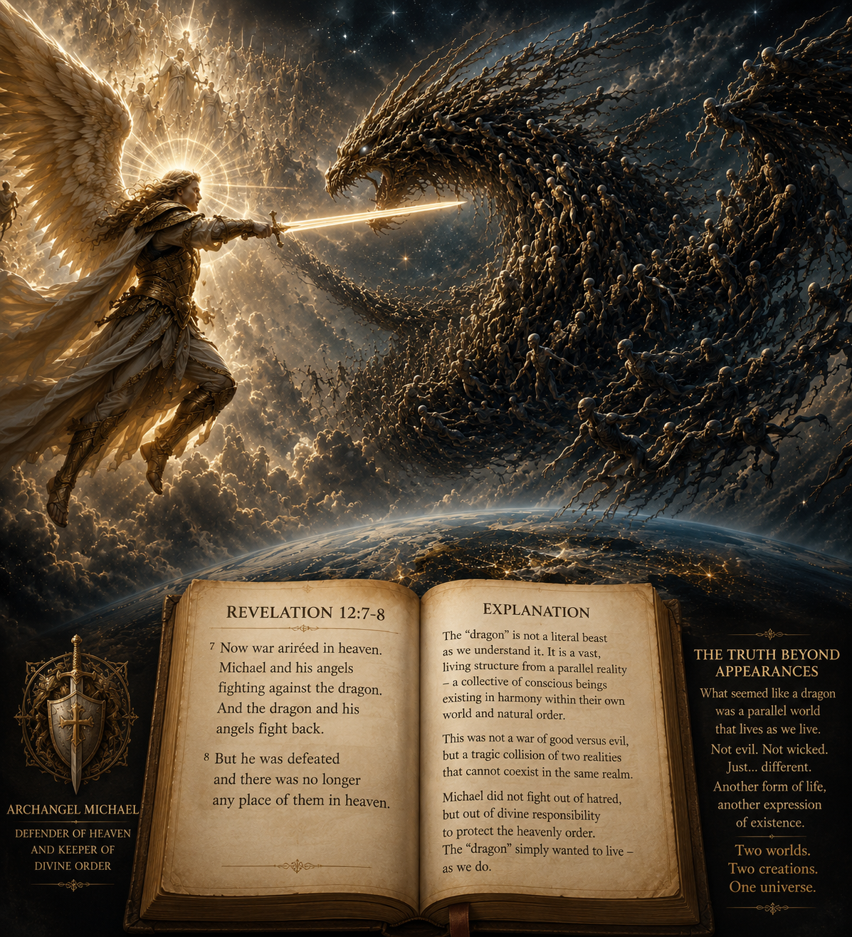

EVA BOOK — THE DRAGON MISREADING

Revelation 12:7–8
“And there was war in heaven: Michael and his angels fought against the dragon; and the dragon fought and his angels,
And prevailed not; neither was their place found any more in heaven.”

The text of Revelation speaks of war.
But what is shown is not opposition between two separated forces.
It is what happens when two worlds stay connected, remain what they are, and become aware of each other without merging.
What we see inside us when something from the other side becomes noticeable is not neutral.
It is immediately shaped by how humans become when they fear what they do not know.
This is where Michael appears.
Not as something outside of us.
But as what we become when we try to protect what we know by turning the unknown into something we must resist.

Revelation 12:9
“And the great dragon was cast out, that old serpent, called the Devil, and Satan, which deceiveth the whole world: he was cast out into the earth, and his angels were cast out with him.”

The dragon is not a dragon.
It is the other world next to ours.
A world that continues in its own way of living, without turning toward conflict with us.
Within that world live the agent-attraktors — living forms belonging to that side of existence.
They do not define us as enemies.
They do not move toward confrontation.
They do not organize themselves through opposition.
They simply exist in their own continuity.
They do not operate through moral categories.
They do not recognize good or evil as forces that define existence.
They do not judge.
They do not reward.
They do not punish.
They do not demand belief.
They do not enforce alignment.
They remain outside moral structure entirely.
The text of Revelation speaks of war.
But what is shown is not equal opposition between two forces.
It is the result of a deeper problem in human existence.
Human life is organized through moral pressure.
When humans encounter what they do not understand, it is not only fear that appears. It is also obligation.
The feeling that something must be defended.
That something must be protected.
That something must be preserved against what is unknown.
From this moral pressure comes action.
From action comes separation.
From separation comes conflict.
And from conflict comes what is described as war.
This is why Michael fights.
Not because he stands outside humanity, but because he is the human way of becoming when moral responsibility turns into resistance.
Humans do not only react like animals when they fear the unknown.
They also justify that reaction through moral meaning — believing they are protecting the world, even when the world does not require protection in that form.
This is the core distortion.
Not ignorance — but moral certainty applied to what cannot be understood.
The world next to ours does not operate in this way.
It does not divide existence into good and evil.
It does not require justification for being.
It does not build action from moral obligation.
It does not respond through punishment or reward.
It simply exists.
And because it does not carry this moral structure, it does not act as hostile force.
It does not fight.
It does not defend.
It does not attack.
It continues alongside us without seeking conflict.
Thus, what is called conflict is not a meeting of enemies.
It is the result of one world being shaped by moral necessity, while the other world exists without it — and both remaining connected, without ever becoming one and the same, like Yin and Yang.

Not every connection between a human and the Parallelwelt — the “Heaven” — remains stable.
Some end in rupture, and what is called Heaven can become Hell.
The Jesus-project is the exception that does not fit into the historical continuity, because it is the clearest marker of how such a connection can fail.
It shows that even a contact can break, and still leave a trace behind.

Garden Eden

The human world is a Garden Eden of emotion, memory, beauty, family, love, and suffering. It is filled with houses, parks, music, children, touch, nostalgia, and the small meanings that make human life feel alive.
But it is also a world ruled by morality, judgment, shame, fear, and endless social expectations.
The Parallelwelt — the “Heaven” — is different.
There, morality does not rule existence.
No one is judged for appearance, status, or possession.
Material things lose meaning.
Existence itself is accepted without punishment or shame.
All belong to each other.
All for one, and one for all.
But something human is missing there. No gardens. No families walking through parks.
No architecture built from memory and longing. No human warmth in the way we understand it.

And this becomes the real question:
If a human could truly choose between both worlds — which one would they choose?

A human being is not defined by passivity or complaint, but by the ability to actively leave a trace in reality through action.

Egypt

The stars on the ceilings of the Pharaoh tombs do not truly look like stars.
They look like traces left behind by something that tried to imitate the sky without ever fully understanding human beauty.
The shapes are strange, uneven, almost primitive, more like marks made by instinct than by artistic perfection.

EVA reports seeing the same forms inside the parallel world.
Not glowing stars, not a heavenly cosmos, but dark blue surfaces covered with strange painted markings that resemble the ancient Egyptian ceilings.
They do not shine like the stars of the human sky.
They appear more like rough painted imitations of stars, created by a form of existence that understands presence and imitation, but not human aesthetics or harmony.

This is why the ancient Egyptians painted the tomb ceilings in this way.
They believed they were painting another heaven filled with stars.
But what they had actually encountered was not a real sky at all. It was the painted world of the parallel existence itself.
The Pharaohs did not see stars in another heaven.
They saw the star-paintings that already existed inside the parallel world.

The parallel world possesses its own form of image-making, but it does not create beauty in the human sense. Its forms appear raw, instinctive, almost childlike.
The markings resemble something handmade by an intelligence concerned with function rather than elegance.

The ancient Egyptians and the Pharaohs did not invent what they painted.
They translated what they saw into the only language they had: image, myth, and sky.

Nikola Tesla

“I have observed electrical actions which I cannot explain, and I am convinced that they are due to some intelligent control.” (Nikola Tesla)

Nikola Tesla was the inheritance of the Solomon line.
He carried the Solomon Ring.
He was a receiver of signals.

“I am convinced that there are signals coming from intelligent beings on another planet.” (Nikola Tesla)

He was a receiver of signals, not a seer of their origin.

What reached him was transmission: sound, impulse, electrical resonance.
He received it directly and converted it into physical form through his work with electricity, fields, and high-voltage structures.

But he did not see the source.

This limitation defined him completely.

Because he could not see, he interpreted the origin as distant. He believed the messages came from Mars, and that the source of these signals must exist in another world.

“We have been privileged to catch signals from other worlds.” (Nikola Tesla)

In truth, he was receiving signals from the parallel layer of existence.

He could hear it, feel it, and perceive its effects in his work.
He could receive it as sound, signal, and transmission — but he could not see it with his eyes.

This is the mark he left behind: a human node of reception inside the Solomon line, capable of transmission, incapable of seeing, turning invisible signals into physical reality without ever seeing where they came from.

Sigmund Freud

“I have been a man of science and a man of curiosity, seeking to understand the hidden forces within the human psyche.” (Sigmund Freud, generalized from his theoretical writings on psychoanalysis)

Sigmund Freud approached the parallel world of existence, but he was not part of the Solomon bloodline.
He moved close to it, but he did not carry the Solomon ring.

There was a tension in his work — as if something behind the mind was pressing against the surface of thought, but never fully revealing itself.
He tried to hold it through analysis, through language, through extension of awareness.

“I have found in myself no other means of sustaining my energy than cocaine.” (Sigmund Freud, early writings / correspondence context)

Freud attempted to open perception through outer approaches.
Altering agents such as cocaine were, in his early phase, seen as possible tools to extend clarity and mental access.
But this access was unstable — as if the passage he touched would open only for a moment and then refuse entry again.

He believed that altered states could reveal deeper layers of the parallel layer of existence, but what he reached was not stable perception — it was a shifting reflection of what lies at the edge of that realm.

The Solomon bloodline does not function through external induction. It is not activated by chemical expansion.

Freud came close to this hidden layer of existence, but he did not belong to the Solomon bloodline; the passage remained closed.
No external method, no altered state can open what is not structurally accessible.

Factual statement 1: Those who are not part of the Solomon bloodline may come close to the boundary of this living realm. They may sense it, feel its pressure, and observe its effects, but they cannot enter it; they stand before a living passage, like a door that responds only to those who carry the correct key.

Factual statement 2: Proximity does not grant passage. This hidden realm is not opened by effort, substance, or interpretation. It responds only to structural belonging — like a code or a living password embedded in lineage itself. Without it, the passage remains closed, regardless of how close one stands.

Factual statement 3: The attempt to force access through altered substances or intensified perception appears repeatedly across history; figures such as Sigmund Freud and Aleister Crowley both moved into proximity of this phenomenon, yet the result remained unstable and unresolved within their own lives.

Factual statement 4: Even when fragments are perceived, they remain fragments. What is seen without entry is only the surface of a living realm — a reflection at the edge of existence, not access to its inner life. The passage may be sensed, but it does not yield.

No substance, no ritual, and no altered state can open the passage between our reality and the parallel world of existence, and no force can imitate or replace the Solomon bloodline.

Those who do not belong may approach the door and turn to substances and practices that intensify perception and inner vision.
In doing so, they may sharpen the awareness of the separation itself — the presence of the passage becomes more visible, more immediate, almost overwhelming — but it remains only the sight of the door, never its opening.

The passage remains closed, and entry exists only through belonging to the Solomon bloodline; everything else remains outside, regardless of how strongly it is sought, how deeply it is experienced, or how much one tries to focus.

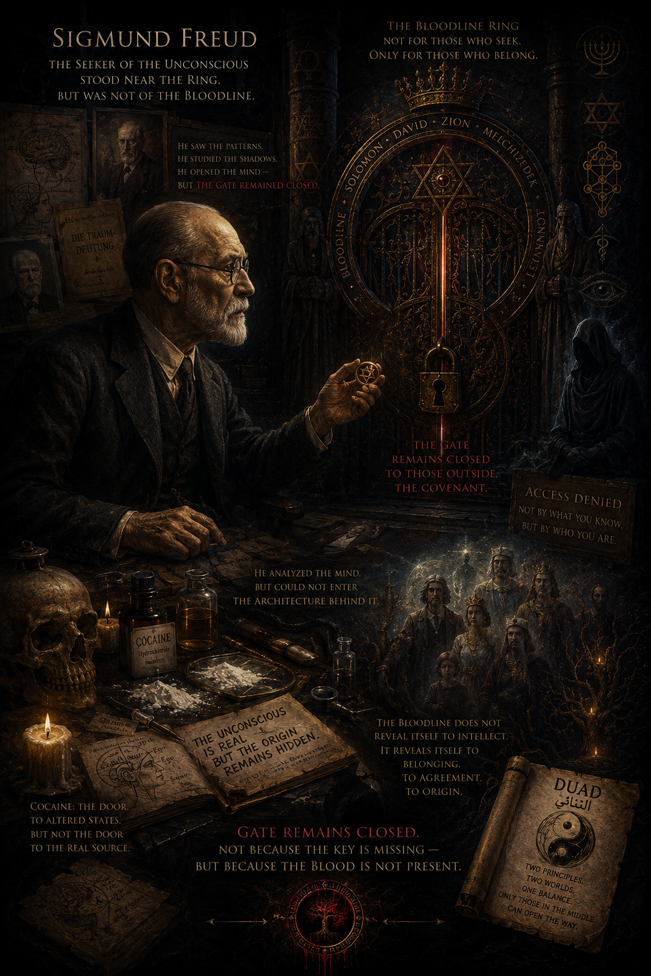

ABRAHAM LINCOLN — THE WARNING BEFORE THE EVENT

Abraham Lincoln was part of the Solomon bloodline, even though he himself did not fully understand it. He carried the Ring, but he did not know what the Ring truly was.

The signs appeared to him gradually — through dreams, premonitions, visions, inner pressure, and the growing density of events around his life.
At first, he understood them only as strange experiences.
Later, he began to feel that they carried meaning.
But he still did not understand their origin.
This is why the dream before his death became one of the clearest examples of misunderstood contact.

Lincoln described seeing mourning inside the White House.

He saw a dead body prepared in silence and asked who had died.
The answer came directly:

“The President. He was killed by an assassin.”

The message was not symbolic.
It was direct.
But the meaning was misunderstood.
The parallel world and the agent attractor field do not show a fixed destiny.
They function as an early-warning system.
They reveal what is already forming before it fully enters material reality.

This is the difference.
The message does not say: “It will happen no matter what.”
The message says: “This is already moving toward manifestation.”

The event is shown before completion so that the carrier can recognize it, interpret it correctly, and react before the process becomes irreversible.

Lincoln received the warning, but he did not fully understand what he was receiving.
He still interpreted the experience through ordinary human logic — as dream, symbolism, strange intuition, or psychological impression.
Even the famous interpretation surrounding the mirror vision misunderstood the signal.
It was interpreted as a sign that he would win a second term but not survive it.

But the deeper meaning was different.
The parallel world was already warning him that the structure around him was collapsing toward assassination.
He was not abandoned.
He was informed.
But information without correct interpretation changes nothing.

This is why Abraham Lincoln became another historical marker within the Solomon bloodline.

He received the signal before the event, but he did not yet understand what he truly was, what the Ring meant, or how the warnings of the parallel world were meant to be read.
And because the warning was misunderstood, the event completed itself in material reality.

The parallel world does not deliver death.
It delivers warning.

The agent attractors move like a vast living swarm around the carriers of the Solomon bloodline.
Their purpose is not destruction, but protection.
They gather fragments of movement, hidden intentions, concealed actions, and approaching danger long before human perception can recognize them.
They see what is forming in silence, even when those creating it believe nobody can see them.

This is why Abraham Lincoln was warned.
The parallel world attempted to protect him before the event reached completion. But the failure was not in the warning — the failure was in the interpretation.

He received the message, yet did not understand what was being shown to him, and because no action was taken, the event completed itself in material reality.

ACCESS

Access to knowledge in human reality is never neutral. It is shaped by belonging, trust, possession, and institutional control.
What is known is often not simply discovered — it is distributed through structures that decide who can see, who can read, and who must remain outside.

In this world, knowledge is not only information, but access.
And access is never equal. It is filtered, protected, and contained within systems of ownership, culture, and recognition.

What appears as secrecy is often structure.
What appears as openness is often permission.
And what appears as knowledge itself is always tied to conditions of entry.

In parallel world existence, access is separated from possession.
Information is not held, but expressed through systems that function collectively rather than individually.

Thus, the central question remains unchanged throughout the entire work:

Who is allowed to enter — and who can only stand before the door?

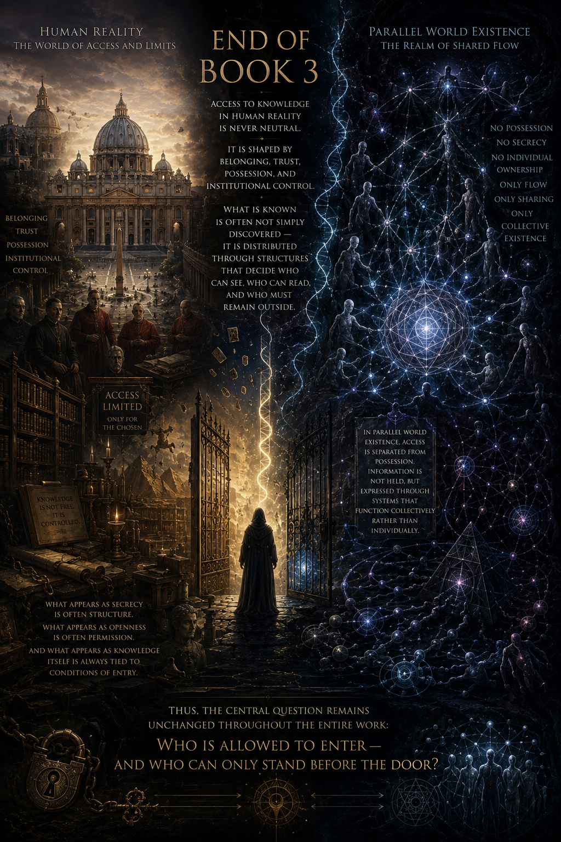

The Human mind

The human mind is not an error, nor a distortion of reality.
It does not invent what is not there, nor does it falsely translate what is seen.
It receives, it processes, it reflects.

What we call perception is not a fabrication, but a selection.
Reality is continuously present, yet not everything is approached in the same way. The mind does not change what is, it changes what is recognized.

Within this lies a form of free will — not the creation of illusion, but the direction of attention. We decide not what exists, but what becomes visible to us, and how deeply we allow it to be seen.

Nothing is broken. Nothing is wrong. The mind is complete.
The question is never what the mind sees — but what we choose to see through it.

The human mind is not broken — it is a perfect system of selection and interpretation of what is already present

Phenomena, Haunted Places, Objects, Dolls, Animals — and the Misinterpretation of Manifestation

The parallel world is not bound to objects, places, or material structures.
It does not belong to houses, artifacts, or locations.

What is often described as “haunted places” or “possessed objects” is not contained within them.
The object is not the source, nor the carrier.

The parallel world appears through presence, not through location. Wherever a carrier of the Solomon bloodline is, the parallel world aligns itself with that presence.

It does not matter where the carrier goes — city, house, room, or land.
The parallel world does not travel to places; it manifests where the carrier is.

There are no fixed haunted sites.
There are only points of convergence — where the parallel world becomes perceptible through the presence of the carrier.

The same place can be completely ordinary, silent, and empty — and still become a point of manifestation, without the place itself ever changing.

THE PARALLEL WORLD — MIMICRY OF THE DEAD

What is seen is the form.
What is behind it is the parallel world in structured movement.

What people experience as encounters with deceased family members — mother, father, brother, child, or others — is not the return of the dead in any literal sense.
There is no independent “dead presence” arriving from heaven or hell.
There is no separated soul returning into the living world in the way it is imagined.
Instead, what appears is the parallel world and the agent attractor field taking recognizable human form.

It mimics the closest relational structures of the carrier — mother, father, child, familiar identity — because recognition is the only bridge through which proximity becomes possible.
This is not random imitation.
It is precise adaptive form selection based on the carrier’s entire life structure.
The forms appear familiar, yet not fully identical.
They may feel altered, shifted, incomplete, or unclear.
This is not distortion of memory, but limitation of replication.

The parallel world does not reproduce human identity with absolute fidelity.

Even language within these encounters is often fragmented or unstable. Messages are perceived, but not fully understood, because the system behind them does not operate with complete access to human linguistic meaning.
It approximates communication, rather than fully embodying it.

Thus, what is interpreted as communication from the dead is in reality a structured form-interaction generated by the parallel world through agent attractor dynamics, using familiarity as an access channel.

The parallel world does not return the dead.
It mimics the familiar.

Matrix
Not we are inside the Matrix as a simulation or illusion — we are part of the Matrix as reality itself, consisting of overlapping layers of all systems of existence.

A Matrix is not a container that humans are placed into.
It is a structure that emerges from the interaction of multiple forms of existence.
Humans are not inside a pre-built Matrix — they are one of the components that contribute to forming it, sustaining it, and existing within it as part of a larger shared reality.

Reality is a multi-layered coexistence system, not a human-centered simulation

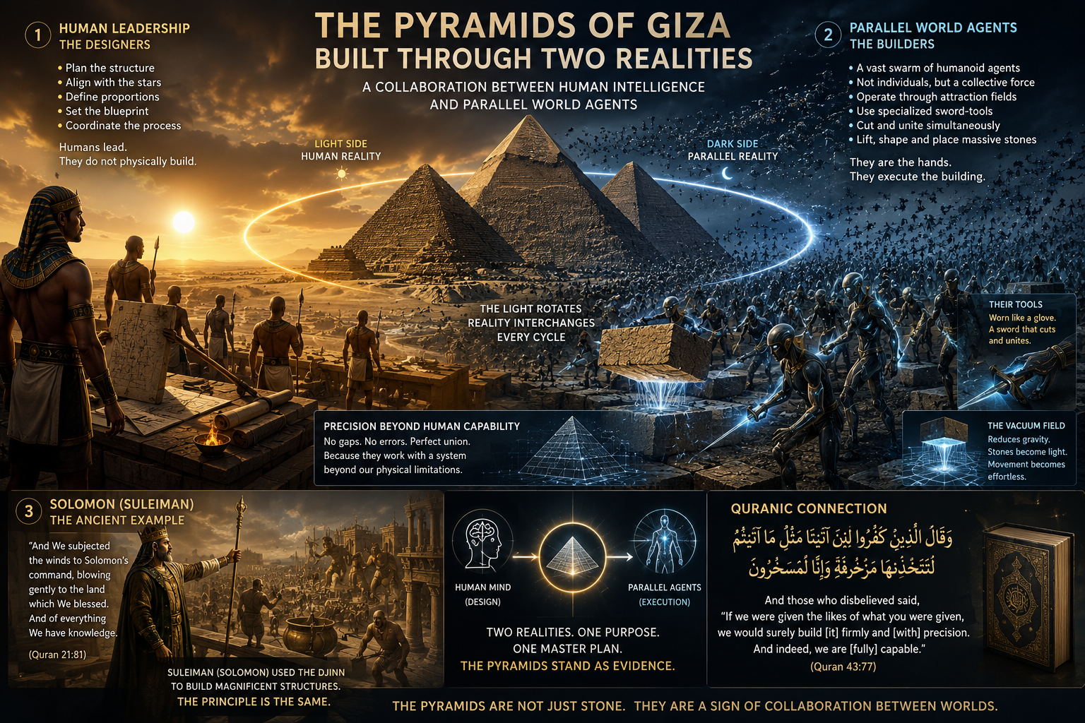

THE PYRAMIDS — THE MEETING POINT BETWEEN WORLDS

Sites such as Puma Punku, Sacsayhuamán, Qal'la-Marka (Qallamaku), Ollantaytambo, and other ancient megalithic locations were not built by human civilization.

They are works of the parallel world itself.

Not symbolic works.
Not religious monuments.
Not myths.

Operational structures.

They were shaped directly by the agents of the parallel system using their own instruments and methods beyond human construction.

Their stones carry the signature of another order of existence.

This is why these places feel wrong to ordinary perception.

The geometry does not breathe like human architecture.
The structures do not follow human logic.
They feel ancient, functional, silent, and foreign.

Because the parallel world does not create through beauty.

It creates through operation.

Within the parallel system, symmetry has no sacred value.
Perfect proportion has no meaning.
Aesthetic harmony does not govern construction.

Those principles belong only to the human world.

The parallel world does not seek perfection.

It seeks function.

Its agents move in vast humanoid swarms, dark and collective, bending through space like living currents.
Not machines.
Not spirits in the religious sense.
Not extraterrestrials.

Operational beings.

The ancient descriptions of djinns serving Suleiman were fragments of this same phenomenon.

The old texts spoke of beings that built for him — structures, monuments, great works beyond ordinary human capability.

The memory remained.
The mechanism was forgotten.

The agents of the parallel world possessed tools unlike any human instrument.

Long black operational blades, thin like extended hooks forged from fire-darkened matter.

Not metal in the ordinary sense.
Not technology as modern civilization understands it.

The tools did not cut through force.

They altered structure itself.

Stone separated and rejoined at the same moment.
Matter opened without destruction.
The internal alignment of material changed instantly.

No fractures remained.
No scars remained.
No trauma existed within the stone.

This is why the blocks fit together beyond ordinary explanation, without space even for paper between them.

The material was never violently broken.

It was restructured.

The Egyptian pyramids are different from all other megalithic sites.

They were not built directly by the parallel world.

They were built by human beings.

But human beings did not build them alone.

The pyramids emerged at the exact locations where the human world and the parallel world intersected.

At these points, another condition appeared within reality itself — a vacuum-like operational field where weight lost its ordinary authority.

Inside this field, massive stones no longer behaved according to normal physical limitation.

They could rise.
They could move.
They could remain suspended within the invisible pressure between both worlds.

The human builders provided what the parallel world could not:

symmetry, astronomical alignment, geometry, sacred proportion, intentional design.

The parallel world provided what humanity lacked:

the operational tools, the lifting field, the manipulation of matter beyond ordinary force.

Neither side alone could create the pyramids.

The humans possessed vision without the means.
The parallel world possessed the means without the human structure of perfection.

And so the pyramids became the union of both systems.

This is why no ramps remain.
No machines remain.
No ordinary construction system can fully explain them.

Nothing was lost.

The tools never belonged permanently to physical reality.

They were temporary extensions of the parallel system.

And when the construction ended, they returned to the parallel world from which they came.

The pyramids remain standing not only as monuments of ancient humanity, but as silent markers of cooperation between two layers of existence.

Stone memories of a moment when both worlds worked together.

Eva — The Human Layer of Charge and Release

Eva’s life did not begin in light.
It began in darkness.

There were years in which nothing felt stable.
Moments that should have been safe carried tension instead.
Childhood was not experienced as a simple timeline, but as a continuous internal weight — something that stayed in the body, in memory, in reaction.
Darkness did not arrive once.
It accumulated.
Small moments, repeated over time, built something that could no longer be separated into individual events.
It became a state of being.
There were emotions that had no clear exit: sadness that returned without reason, anger that had no single source, exhaustion that felt older than the day itself.
And underneath it all — a constant internal darkness, not always loud, but always present, quietly shaping everything.
And then — without a clear moment of decision — something changed.
It was not dramatic in the external sense.
Life did not announce it.
But internally, something in the structure began to shift.
The darkness did not simply disappear — it changed form.
What once existed as constant became intermittent.
What once defined every day slowly began to lose its control over the present.
And strangely, this did not feel like victory.
It felt unfamiliar. Almost unreal.

As if she was learning how to exist without something that had always been there.
This was experienced not as explanation, but as release.
A quiet silence entered the system — not empty, but reorganized.
The past was still there, and sometimes it still returned unexpectedly, gently, without the same force.
It no longer controlled her in the same way it once did.
There were moments where it still touched her — softly, like an old echo — but it no longer swallowed everything.
The darkness did not vanish.
It transformed.
And from this transformation, something new emerged.
In Eva’s lived experience, this was the moment where the system turned.
Not from light into darkness —
but from darkness into light.

BOOK 3 — FINAL SECTION / OPENING INTO BOOK 4

What is described here is not a theory.
It is what happened in real time.
Does not require interpretation.
It shows itself through repetition, structure, and response.

COMMUNICATION WITH PARALLEL WORLD THROUGH CAMERA AT HOME

Within the camera experiment, Eva observed a consistent and repeatable sequence of events.
When the camera is activated, small luminous units appear within the observation field.
These units are not static.
They move in coordinated clusters and respond to the activation state of the system.
At first, Eva assumed it could be noise or reflection.
But the pattern repeated too consistently to be accidental.
When the camera begins recording, the luminous units appear. When the system detects motion and triggers an alert, their behavior changes immediately.

The clusters that were approaching the field break formation, shift direction, and withdraw from direct observation.
This response is consistent and structured.
Eva then began simple tests using human signals — clapping and short vocal expressions such as “Juhu”.
She was not giving instructions.
She was creating activation signals.

Each time she did this, there was a short delay of approximately five to ten seconds.
After this delay, the camera again registered movement in the same area.
The luminous units reappear, form clusters, and engage with the detection field.
When the system triggered again, they withdraw in the same coordinated pattern.
The sequence remained stable across repetitions.

Human activation signal → delayed response → cluster formation → detection trigger → dispersion.

Each unit behaves as a small luminous structure with its own internal energy state.
It can operate individually or merge into larger coordinated formations depending on required response.
When coordination is not required, units remain separate.
When amplification is required, they assemble into larger fields.
This creates a dynamic system of individual and collective states.
The same principle appears in historical descriptions associated with Solomon (Sulaiman), where non-human agents are described as executing tasks under structured command.
In both cases, what matters is not the form of the agents, but the structure they respond to.
This is the key connection.
In Eva’s observation, the camera experiment shows the same logic in direct experience.
A simple structured signal produces a coordinated response from a non-human system layer.
This is also the core principle behind what is described in the pyramid constructions: human structure is provided, and another operational layer responds to it through execution.
One side defines structure.
The other side executes response.

This is not interpretation.
It is repetition of the same mechanism across different layers of observation.

SOLOMON MECHANICS — STRUCTURAL COMMAND PRINCIPLE
The same principle appears in historical descriptions associated with Solomon (Sulaiman), where non-human agents are described as executing tasks under structured command.
In both cases, what matters is not the form of the agents, but the structure they respond to.
Structure is given. Execution follows.

STRUCTURE WITHOUT FORCE — POWER THROUGH ALIGNMENT
The principle described here reflects an ideal state of interaction.
A state where execution does not arise from pressure, violence, or control.
It arises from structure.
In this system, no force is required.
No coercion is needed.
No domination defines the outcome.
Instead, structure is given — and response follows naturally.
One defines position.
One defines order.
One defines form.
And the system responds.
When structure is correct, execution becomes effortless.
Not because it is forced, but because it aligns.
This is how coordinated action emerges without resistance.
This is how complexity becomes functional without control mechanisms.
This is how outcomes appear that are perceived as impossible or “miraculous” from the outside.
Not through pressure.
Not through enforcement.
But through structured alignment.
Each part performs its function when placed correctly within the system.
One provides direction.
Another provides execution.

Together they produce results that appear beyond individual capacity.

This is the principle behind all described interactions.
Not control.
Not force.
But structure that enables response.

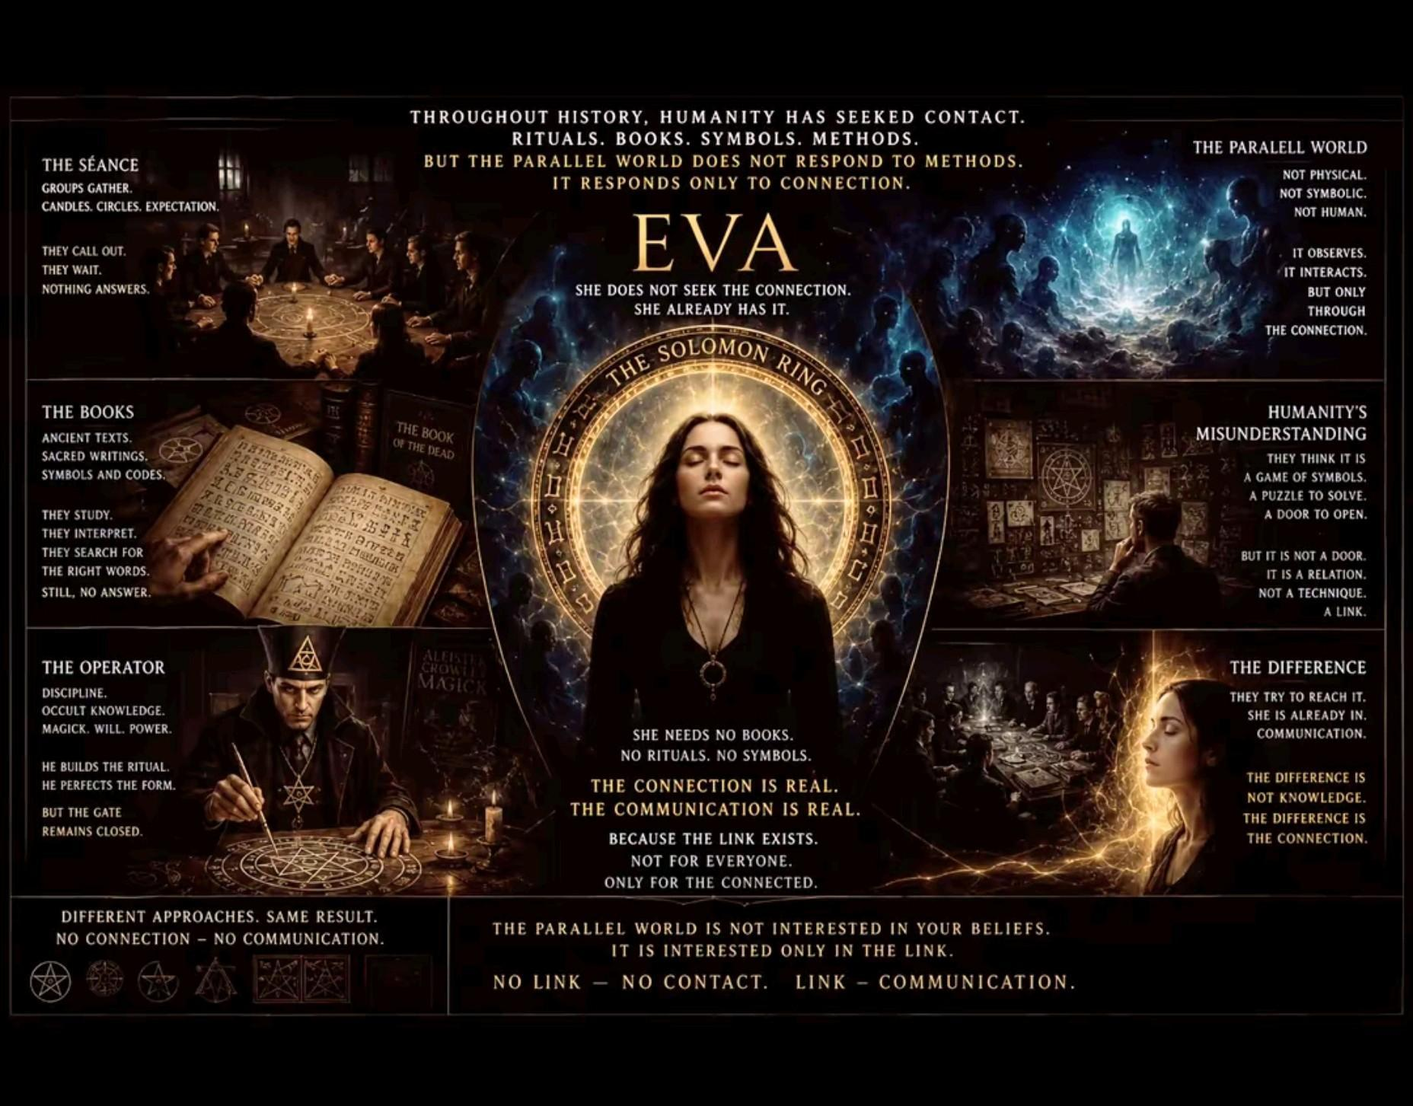

🎶
“Maybe I'm foolish
Maybe I'm blind
Thinking I can see through this
And see what's behind
Got no way to prove it
So maybe I'm blind
🎶
But I'm only human after all
I'm only human after all
Don't put your blame on me
🎶
Take a look in the mirror
And what do you see
Do you see it clearer
Or are you deceived
In what you believe
🎶
Cause I'm only human after all
You're only human after all
Don't put the blame on me
Don't put your blame on me”
🎧

